**NIRF Dashboard: Web Application and Services**

**Enrollment Nos.:** 13503862

**Name of Students:** Rajat Dhiman

**Name of Supervisor:** Dr. Sandeep Kumar Singh



**Submitted in partial fulfillment of the Degree of**

**5 Year Dual Degree Programme B. Tech**

**in**

**Computer Science Engineering**

**DEPARTMENT OF COMPUTER SCIENCE ENGINEERING & INFORMATION TECHNOLOGY**

**JAYPEE INSTITUTE OF INFORMATION TECHNOLOGY**

**CERTIFICATE**

This is to certify that the work titled **“NIRF Dashboard: Web Application and Services”** submitted by “**Rajat Dhiman and Anubhav Keshav**” in partial fulfillment for the award of degree of **5 year Dual Degree Programme B. Tech** of Jaypee Institute of Information Technology University, Noida has been carried out under my supervision. This work has not been submitted partially or wholly to any other University or Institute for the award of this or any other degree or diploma.

**Signature of Supervisor: ________________________**

**Name of Supervisor: Dr. Sandeep Kumar Singh**

**Date: ________________________**

**TABLE OF CONTENTS**

**Chapter No. Topics Page No.**

**1** **Introduction of Web and Cloud Services 4**

**2 Class Diagram of Composite Service 5**

**3 Use Cases of Web and Cloud Services 6**

**4 Sequence Diagram 7**

**5 Component, Deployment and Package 8-9**

**Diagram of Web and Cloud Services**

**6 Application of Design Patterns 9**

**7 Snapshots, GUI and code snippets 10-17**

**Chapter 1: INTRODUCTION**

This project is based on the government website [www.nirf.in](http://www.nirf.in) which makes use of the dataset from this website. The web application is basically a dashboard which provides the user with various options to compare the data of various universities in a graphical form and perform various functions on this dataset. The NIRF website consists of tables that contain data in the form of pdfs for every university. This dataset consists of the rankings and various details of all the colleges of India, private as well as public colleges.

In this project, I have made use of various visualization techniques like Geometric Techniques and Graph-Based Techniques to show the compared data of various universities in the form of different graphs like pie charts, straight line graphs etc. The web application developed is of great use to the individuals who need to compare different data of around 100 colleges in a single visualization in the form of graphs. Different computations have been performed on the data set according to the requirements of the user.

The web application developed provides the users to register themselves for the authenticity of the user. In order to achieve scalability, maintain and configure database servers, networks etc., we have made use of Amazon Elastic Beanstalk.

The web service that has been designed gives users the specific or computed data of colleges in JSON downloadable format which can be used by the user in different forms. The web services make use of RESTful services to achieve the required goals.

The technologies used in this project are LARAVEL for the extraction of dataset from the website using crawling techniques and also for the backend, HTML, CSS, BOOTSTRAP are used for the frontend. The graphs are drawn using the PHP library, CanvasJS which makes use of JAVASCRIPT and JSON for data storage, AWS Elastic Beanstalk and RESTful services.

**Chapter 2: Class Diagram of Composite Service**

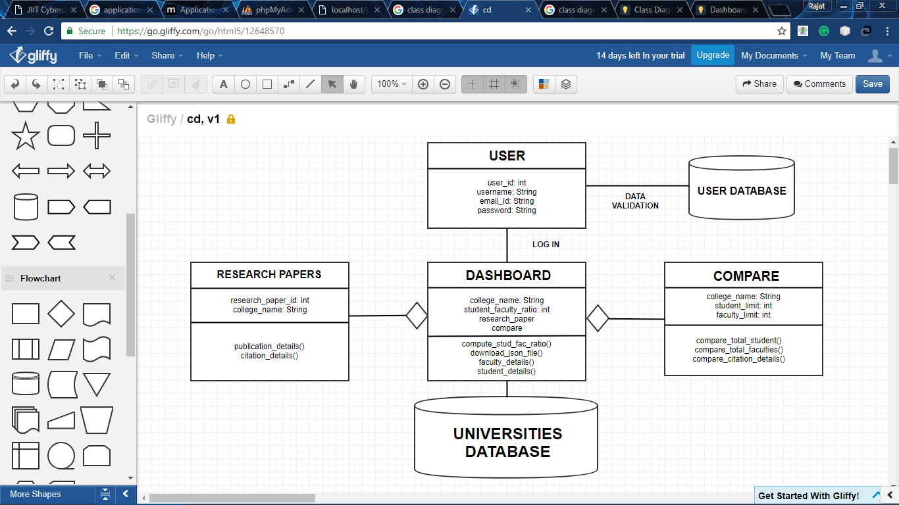

**Chapter 3: Use Cases of Web and Cloud Services**

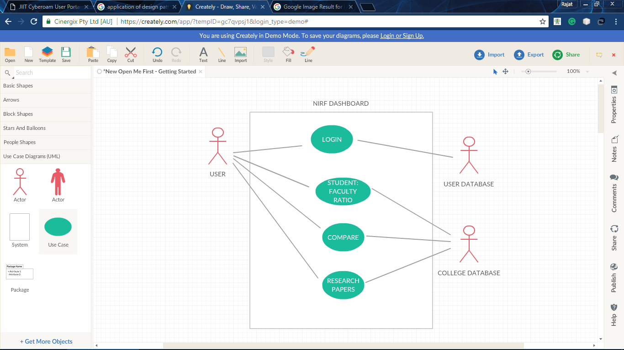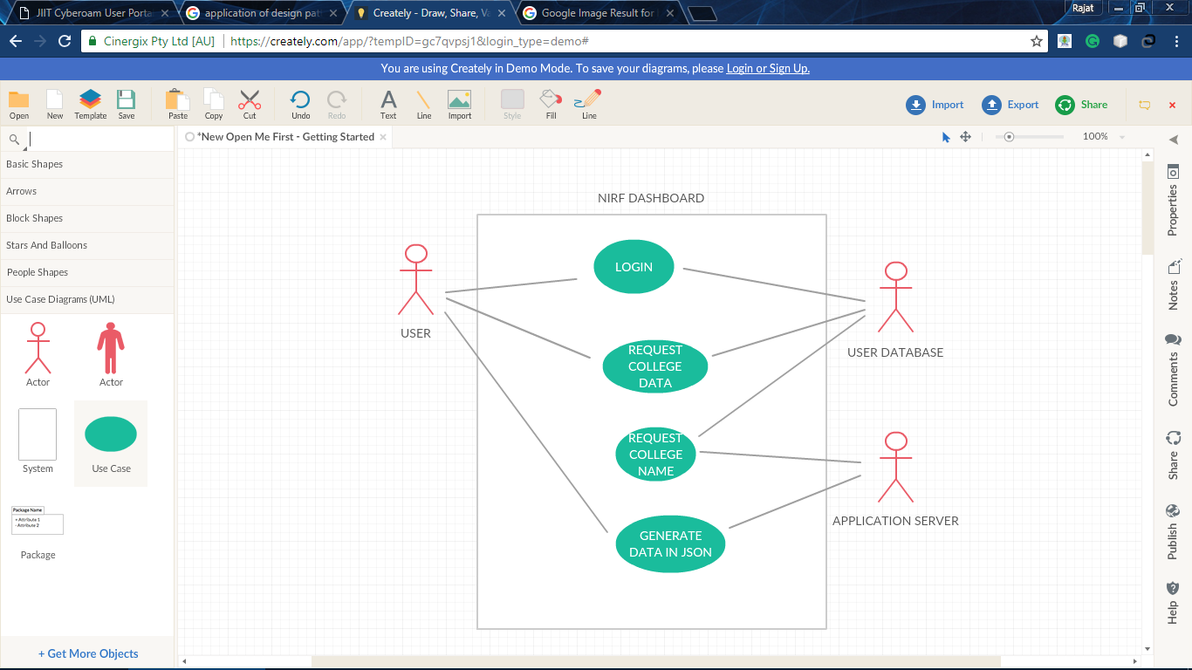

**Chapter 4: Sequence Diagrams**

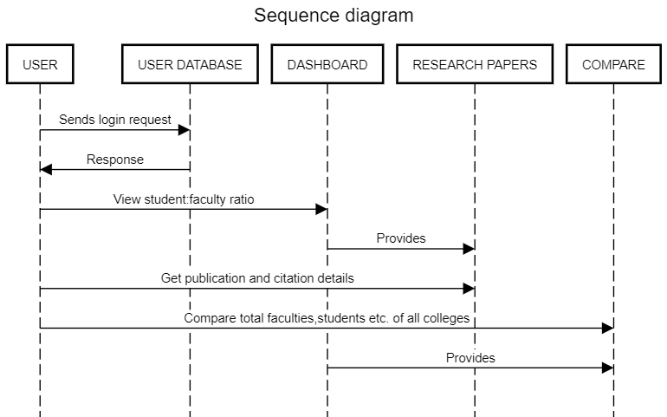

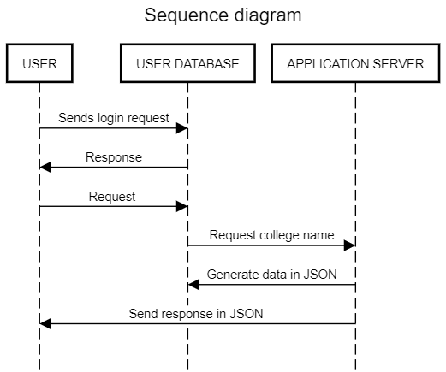

**Chapter 5: Component, Deployment and Package**

**Diagram of Web and Cloud Services**

*Component Diagram:*

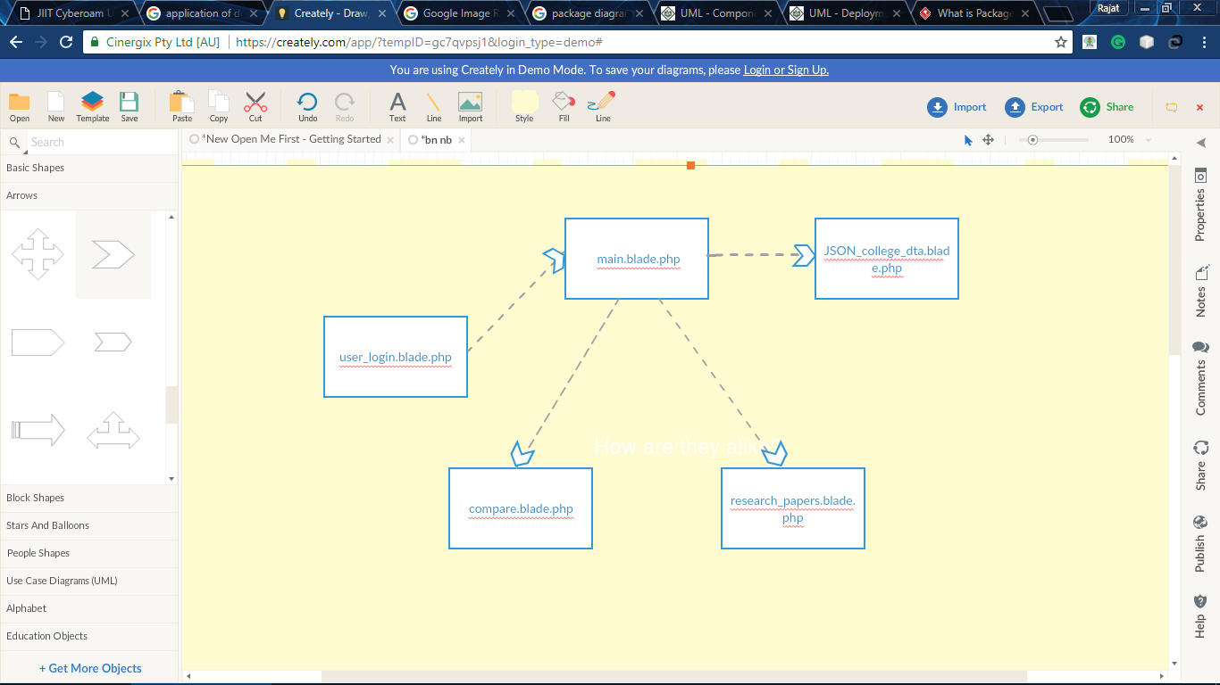

*Deployment Diagram:*

RESTful Services

Application Server

User Database

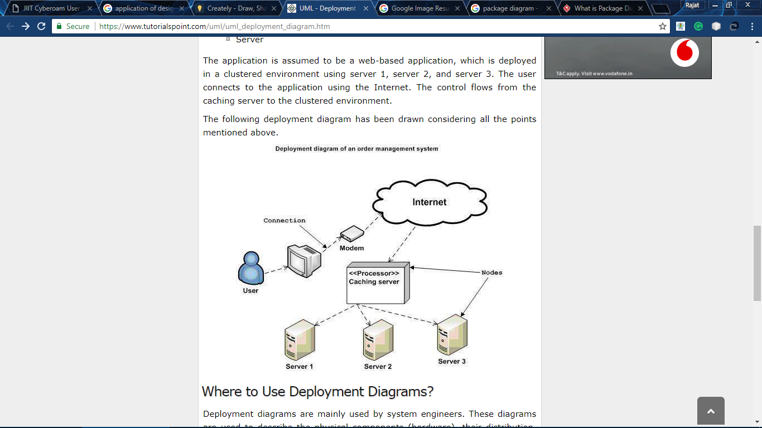

*Package Diagram:*

DASHBOARD

APPLICATION SERVER

Research Papers

Compare

Student:Faculty Ratio

User

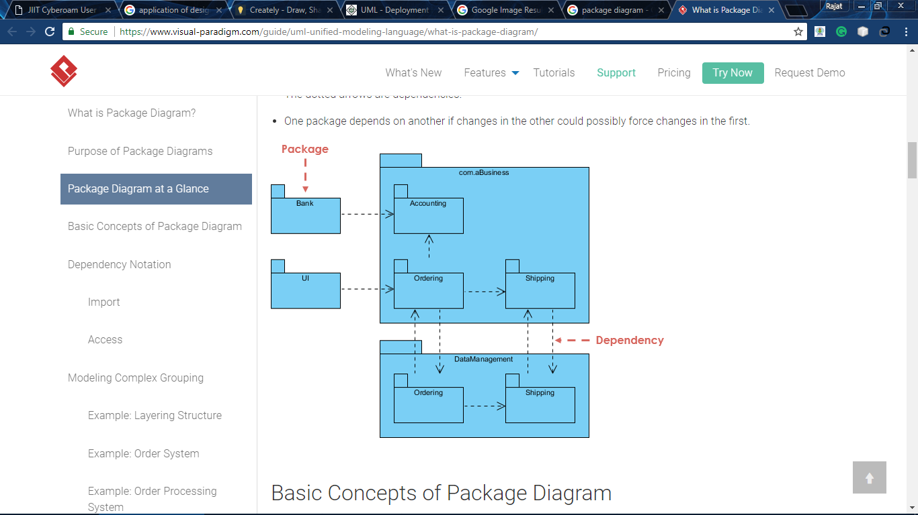

**Chapter 6: Application of Design Patterns**

For more future advancements, we can add more queries to our dashboard which will give the user more and more options for the comparison of various data attributes of various universities.

We can implement more queries in future using other, more interactive data visualization techniques. More web services can be developed which provide more computed data and queries to the user which will reduce the fetching of data from the NIRF website, instead the user will be provided with already computed data for direct use.

This interactive web application can help individuals and universities to compare and work on the data for various purposes which can help the universities to check where they are lacking behind or advancing in the fields of faculties, students, infrastructure etc. If more advancement is made in this application, this application would result into a great help for the universities.

**Chapter 7: Snapshots, GUI and code snippets**

1. The very basic step in the making of this project was to parse the data from the NIRF website which was done using a PHP library which is used to convert the pdf to HTML. Once the dta has been converted to HTML page, the data is scrapped from this HTML page and stored into the localhost server like Wamp or Xamp. This api can be used by anyone to parse the data into their server database.

**Code for parsing data: nirf api**

libxml_use_internal_errors(true);

$doc = new \DOMDocument();

$doc->loadHTMLFile('https://www.nirfindia.org/EngineeringRanking.html');

$xpath = new \DOMXPath($doc);

$elements = $xpath->query("//table[@id='tbl_overall']/tbody/child::tr/td[2]/div[1]/a[3]/@href");

$columns = array(3,11,5,5,4,4,3,3,2,2,3,3);

foreach ($elements as $element) {

#file_put_contents("temp.pdf", fopen($element->nodeValue, 'r'));

#echo $element->nodeValue."\n";

file_put_contents("/temp.pdf", fopen($element->nodeValue, 'r'));

$a = shell_exec("PATH=C:/New Folder (2)/poppler-0.51/bin; && pdftohtml -noframes -nomerge -s C:/temp.pdf C:/temp.html");

$html = file_get_contents("/temp.html");

$doc2 = new \DOMDocument();

$doc2->loadHTML($html);

$xpath2 = new \DOMXPath($doc2);

$counter = 0;

$local_counter = 0;

$tables = array();

$table = array();

$names=array();

$elements3 = $xpath2->query("//p[@class='ft11']");

$elements2 = $xpath2->query("//p[ starts-with(@class, 'ft') and substring(@class, string-length(@class) - string-length('3') +1)='3']");

$gotName=explode(': ', $elements3[sizeof($elements3)]->nodeValue)[1];

$gotName1=preg_replace("/[^a-zA-Z]/", " ", $gotName);

$gotName2=str_replace(' ', '_', $gotName1);

$univName=substr($gotName2, 0,50);

print_r($univName);

foreach ($elements2 as $i => $element2){

array_push($table, $element2->nodeValue);

#echo $element2->nodeValue." ";

$local_counter = $local_counter+1;

$next = $xpath2->query("following-sibling::p[1]",$element2)[0];

if ((!is_null($elements2[$i+1]))){

if ($counter==9 && $local_counter < 6){

continue;

}

if(!is_null($next)){

if (!$elements2[$i+1]->isSameNode($next)){

#echo "<br>";

$local_counter = 0;

array_push($tables, array_chunk($table, $columns[$counter]));

$table = array();

$counter = $counter+1;

}

}

else{

#echo "<br>";

array_push($tables, array_chunk($table, $columns[$counter]));

$table = array();

$local_counter = 0;

$counter = $counter+1;

}

}

else{

#echo "<br>";

array_push($tables, array_chunk($table, $columns[$counter]));

$table = array();

$local_counter = 0; $counter = $counter+1; }}

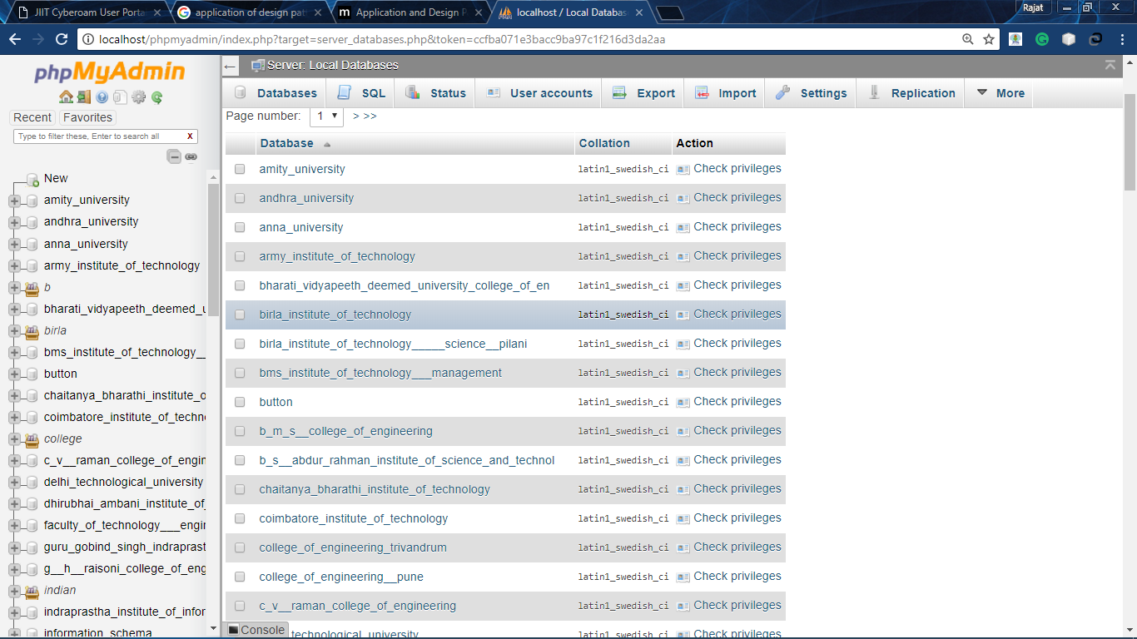

1. Now we have built a web application which firstly prompts the user to login with valid credentials. After logging in the, user is given a dashboard where the user is provided with various options.

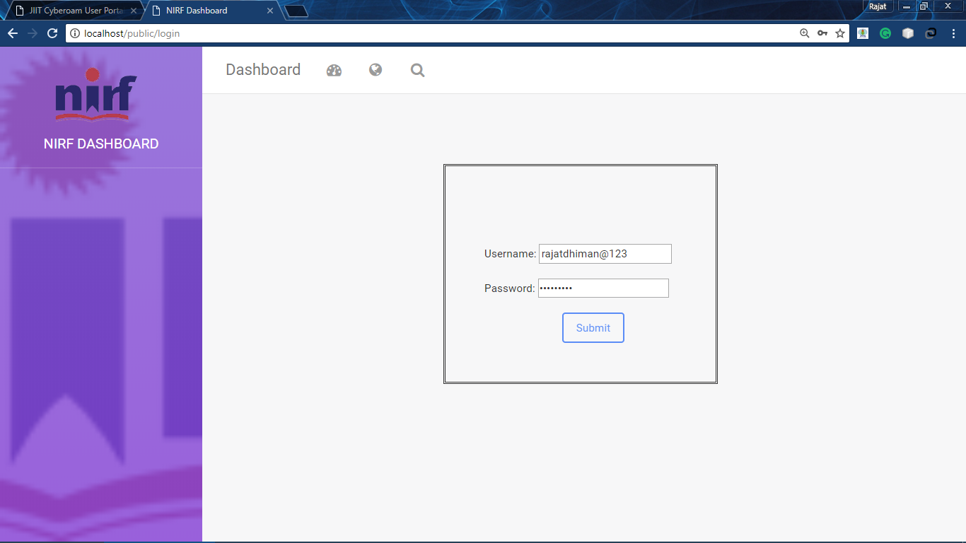

1. After logging in, the user is redirected to the next page which is the main dashboard where the user can first compare the student is to faculty ratio of the desired university.

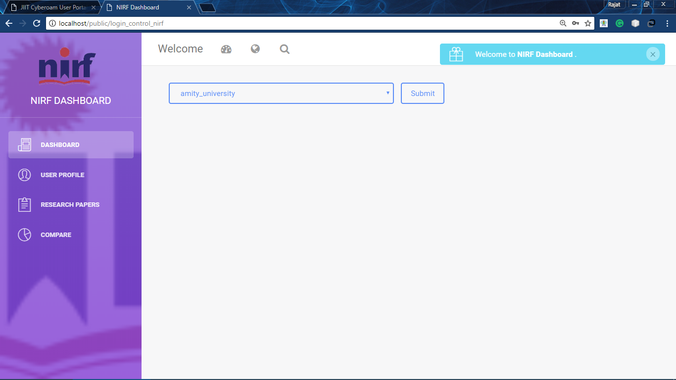

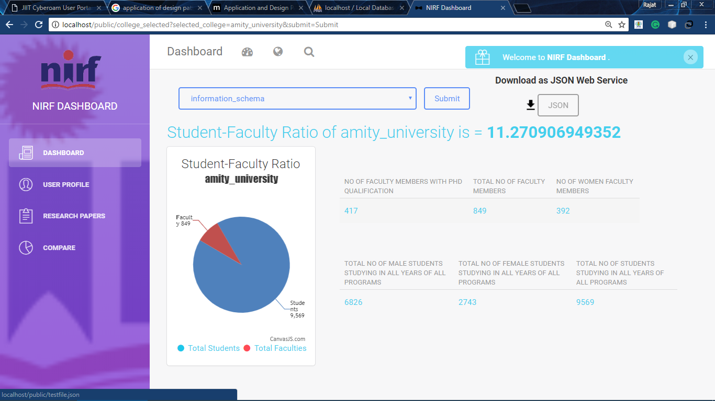

1. On this dashboard, the user is provided with a web service api using RESTful services, using which the user is given the option to download all the computed data along with the available information in the form of JSON file which can be used by the user in displaying the data in the required form or inserting this JSON data into database. The GET and POST methods are required, the user sends the request for the the required college with the name and he gets the associated data in a downloadable JSON format.

*JSON content example:*

{"ratio":11.270906949352,"college_name":"amity_university","total_faculty":849,"total_student":9569}

1. The user can compare the research paper details like publication details and citation details of desired university in the form of pie charts.

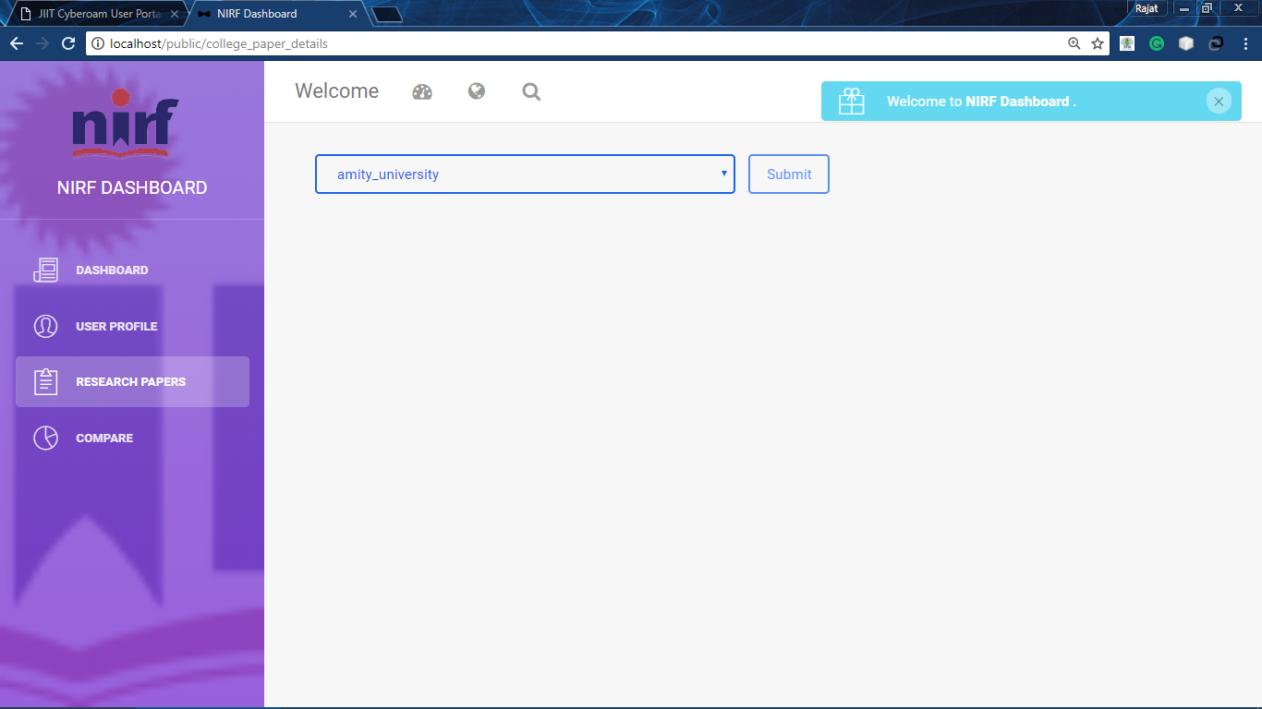

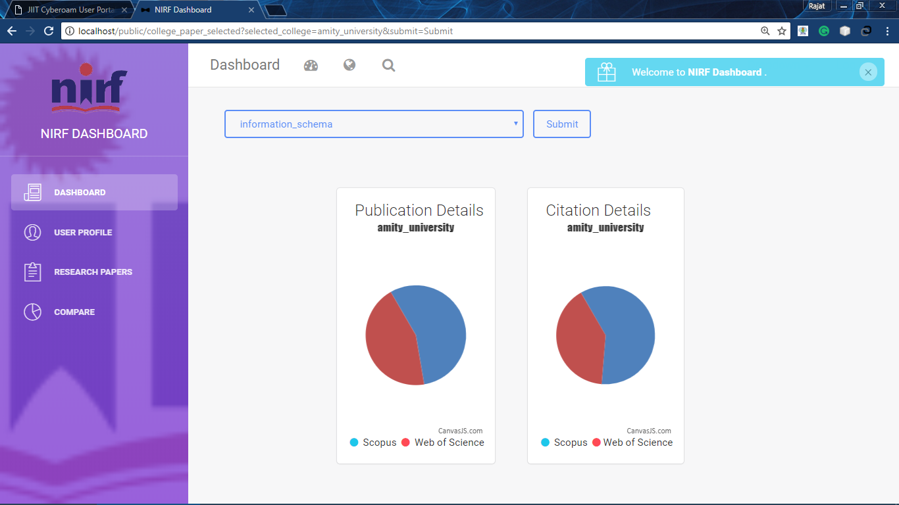

1. The user can go into the compare tab given in the dashboard and various options are provided to the user like to compare the total number of faculties in all colleges, total number of students in all colleges and to compare the consultancy project details of all the universities.

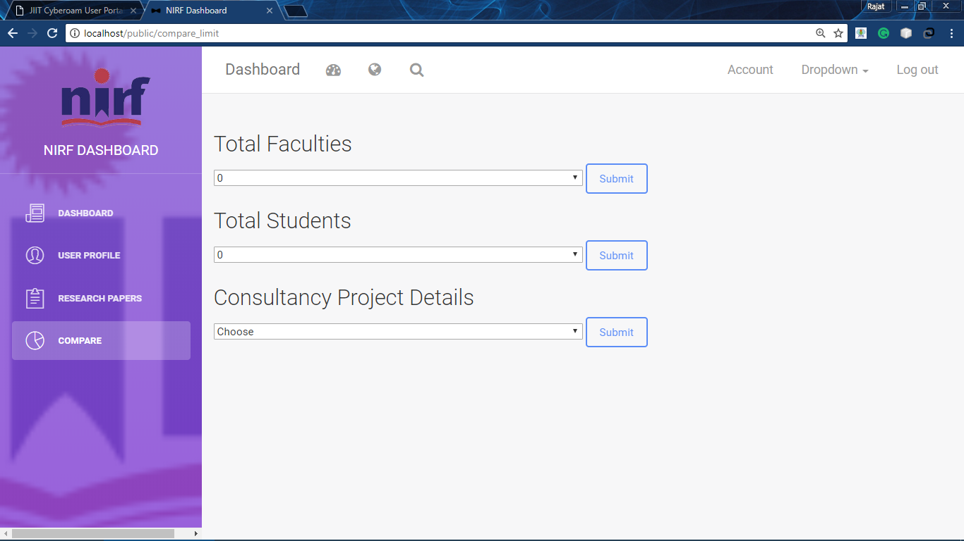

To compare the total faculties of those colleges which have faculties above 800.

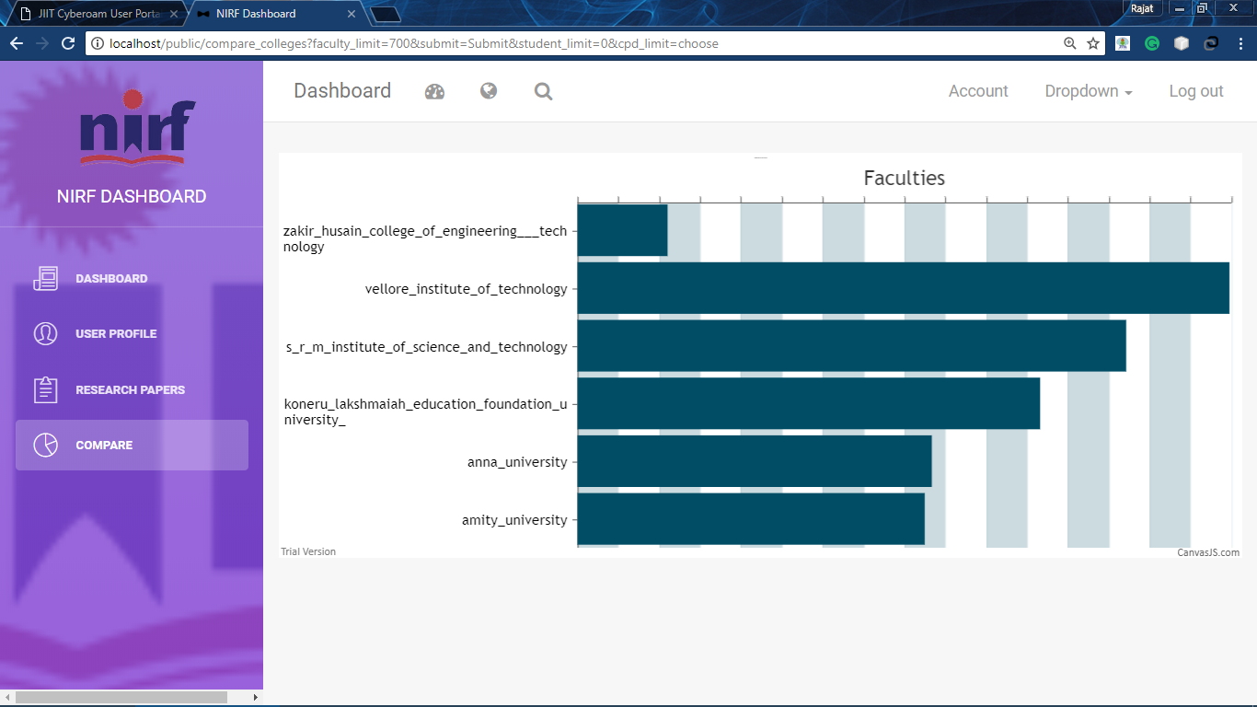

To compare the total students of those colleges which have students above 9000.

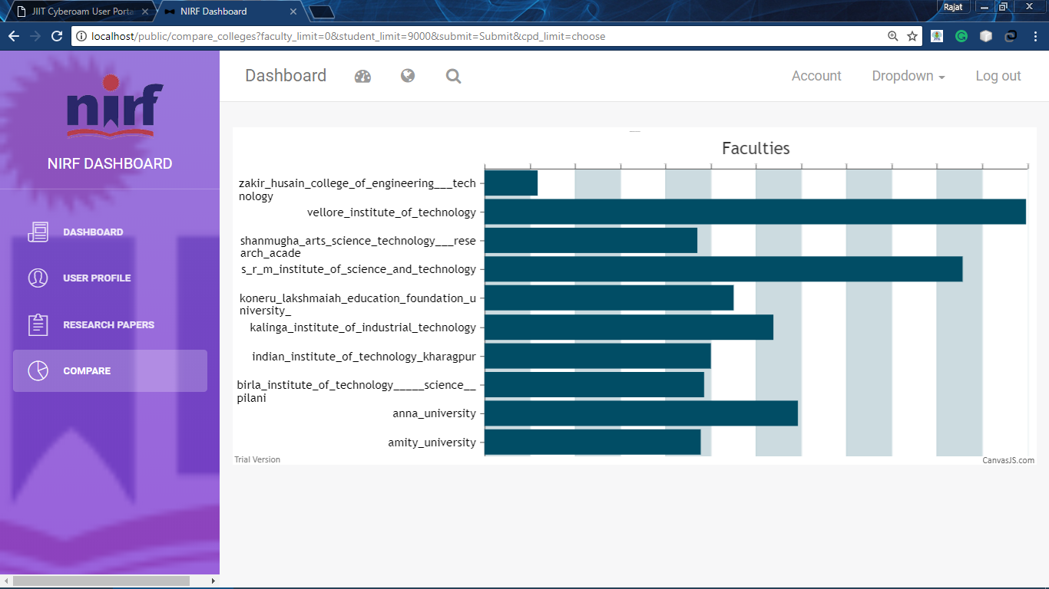

To compare the consultancy project details of all colleges for the year 2014-15.

